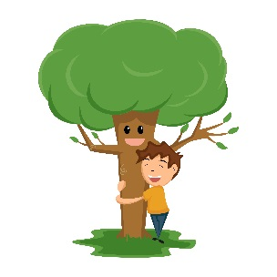
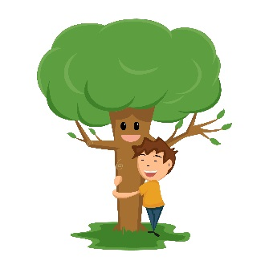
Buffer Maintenance Program
Adapted from Clear Water Conservancy

Objective:
  - Plant and Steward successful trees
  - Establish a forested buffer
    - High tree survivorship
    - Native plant communities (largely)
    - Functioning habitats/ecosystems
  - To have landowners and community members understand, appreciate and value their stream buffers
- Site Steward Skill Set needed
  - Technical Knowledge of plants
    - Learn Native Plants – trees, shrubs, herbaceous
      - What was planted
      - Natural regeneration
    - Learn invasive and competitive plants and their life cycles
      - Herbicide/Mechanical Treatments
        - Which, what, when, where, how OR who to trust to hire
  - Shelter maintenance
  - Fence and Animal damage
  - Seedling survival/Replanting
- Site prep -> install buffer -> 4-6 years of buffer assistance -> land owner maintains buffer
  - Farm/Landowner rules/requirements/requests
  - Responsibility
    - Communicate with landowner (Liaison)
    - Visit properly on a regular basis (monthly)
    - Identify maintenance needs
    - Preform maintenance
    - Communicate additional projects/needs to staff
      - Work crew needed, herbicide contractor, streambank erosion, damage to fences
    - Primary maintenance needs
      - Tree shelter and stake maintenance
        - Straighten shelters
        - Seat shelters in soil
        - Check shelters for damage
        - Evict mice
        - Weed inside shelters
        - Replace stakes or shelters
      - Bird net replacement or removal
      - Track Mortality
      - Replant dead or missing trees & shrubs
      - Identify tasks for contractors
      - Identify tasks for large work crews

CREP CP-22 Riparian Forested Buffer Yearly Maintenance

This is a general guide for tasks that should be completed throughout the entire contract and does not replace the guidance in your conservation plan. Refer to your conservation plan—it contains the official specifications and guidance for your CREP contract. Activities for re-enrollment contracts may vary from this guide. You should consult the Natural Resources Conservation Service (NRCS) or Farm Service Agency (FSA) prior to mowing or applying herbicide to ensure the timing and extent of these activities is allowed. There are restrictions for these activities. In most cases, after year 4 of your contract, you must submit a specific written request to mow or apply herbicide in your buffer. A professional, licensed pesticide applicator may be required for herbicide applications. Always follow product labels and laws when applying pesticide.

January – April: ___ Remove any bee/wasp nests from within shelters before bees become active.
___ After frost heaving has ended, fix any down, damaged, or leaning trees, shelters, and stakes. Redrive stakes into ground and replace broken or rotten stakes. Tighten zip ties.
___ Check and reseat shelters to ensure the bottoms are 1-2” below the ground surface.
___ Remove bird nets from shelters for trees that are within 12”-18” from top of shelter.
___ Remove shelters that are beginning to perforate. Other options: In areas of potential buck rubs, cut the bottom 12” off of shelter but leave remainder of shelter on tree; Slide shelter up tree trunk and reattach it to stake or lower limbs of tree; Cut slit the entire length of shelter but leave shelter on. Which option to use will depend on site specifics.
___ Kick mice out of shelters.
___ Order trees, shelters, and stakes for spring replanting. Order early!

March – early May: ___ Replant trees/shrubs and install or reuse shelters if you did not replant the previous fall.

April – June: ___ Conduct Post Planting Application (PPA) of herbicide around trees/shrubs if within first four years of contract. PPA requires prior FSA approval. See your CREP conservation plan for details.
___Estimate survival of trees in the buffer for future replant (fall or following spring). Must maintain 70% survival of original number planted.
April – June (continued): ___ Mark and tally any missing or obviously dead trees for future replanting (fall or following spring).
___ If within first four years of contract, mow as needed between trees. This is on a case by case basis—consult NRCS prior to mowing. No mowing without FSA permission after year 4 of your contract.
___ Remove bird nets from shelters for trees that are within 12”-18” from top of shelter.
___ Inspect for noxious and invasive weeds. Request permission to mow or spray herbicide from FSA.

August: ___ Conduct Mid-Contract Management (usually only in year 5 of your contract). Consult your conservation plan for details.
___ Control noxious and invasive weeds. Request permission to mow or spray herbicide from FSA.

September – October: ___ Estimate survival of trees in the buffer for future replant (fall or following spring). Must maintain 70% survival of original number planted.
___ Mark and tally any missing or obviously dead trees for future replanting (fall or following spring).
___ Order trees, shelters, and stakes for fall replanting. Order early!
___ If within first four years of contract, mow as needed between trees. This may or may not be needed—consult NRCS prior to mowing. No mowing without FSA permission after year 4 of your contract.
___ Kick mice out of shelters.
___ Fix any down, damaged, or leaning trees, shelters, and stakes. Redrive stakes into ground and replace broken or rotten stakes. Tighten zip ties.
___ Check and reseat shelters to ensure the bottoms are 1-2” below the ground surface.
___ Inspect for noxious and invasive weeds. Request permission to mow or spray herbicide from FSA.
___ Fix any down, damaged, or leaning trees, shelters, and stakes. Redrive stakes into ground and replace broken or rotten stakes. Tighten zip ties.
___ Check and reseat shelters to ensure the bottoms are 1-2 inches below the ground surface.

October – November: ___ Replant trees/shrubs and install or reuse shelters if you did not replant the previous spring.

*If applicable, check and maintain streambank fence, stream crossings, and watering system at least twice per year and after every storm or high-water event.

